***Note1:*** *All labs are mandatory, and you will be marked on 4, randomly chosen out of 11 labs. These will account for 20% of your overall mark (5% each).*

***Note2:*** *If a marker requests for a specific lab (e.g. Lab 3) and you do not have Lab 3 available, you can ask for another lab to be marked (e.g. Lab 2) but the total marks for Lab 2 will be reduced by 50%.*

***Note3:*** *All the labs should be created on one single document following the* [*provided template*](https://portdotacdotuk-my.sharepoint.com/:w:/g/personal/val_adamescu_port_ac_uk/EcxluvfBQCdFiOyaQsPbdzYB4OpU8WcLO52Gcvp4L21pVw)*, saved in your drive (or computer) and accessible anytime. Labs are individual works, and they will be submitted into Moodle Dropbox - see deadline.*

***Note4:*** *If a LAB is not finished in the scheduled session, you should complete it at your most convenient time by the beginning of the next session.*

***Note5:*** *Use a code editor and do not type into VM directly*

*Online documentation:* [*https://devdocs.io/*](https://devdocs.io/)

LAB 1

1. **Which of the following steps occurs first in the process of building an ERD based on a scenario?**
   1. Develop the initial ERD.
   2. Create a detailed narrative of the organisation’s description of operations.
   3. **Identify the attributes and primary keys that adequately describe the entities.**
   4. Identify the business rules based on the description of operations.
2. **A student can attend 5 modules. Different lecturers can offer the same module. The relationship of students → lecturers is a ____________ relationship.**
   1. Many-to-many (M:M)
   2. One-to-many (1:M)
   3. One-to-one (1:1)
   4. Many-to-one (M:1)
   5. Many-to-zero OR one (M:0-1)
   6. **One-to-one OR many (1:1-M)**
   7. Many-to-zero
3. **What would be the cardinality symbol for the relationship identified in Q2?**
   1. ****one to zero or many
   2. one to zero or one
   3.  Many to many
   4. **one to one or many**
   5. One to many
   6. one to one
4. **Which of the following statements best describes the function of an entity relation model?**
   1. An ER model is concerned primarily with the view of the attributes that will be used in physical implementation
   2. An ER model is concerned primarily with a physical implementation of the data and secondly with the logical view
   3. **An ER model provides a view of the logic of the data and not the physical implementation**
   4. An ER model is entirely concerned with modelling the physical implementation
5. **Consider Figure 1 representing instances of a relationship between an EMPLOYEE and the DEPARTMENT that the employees work in.**

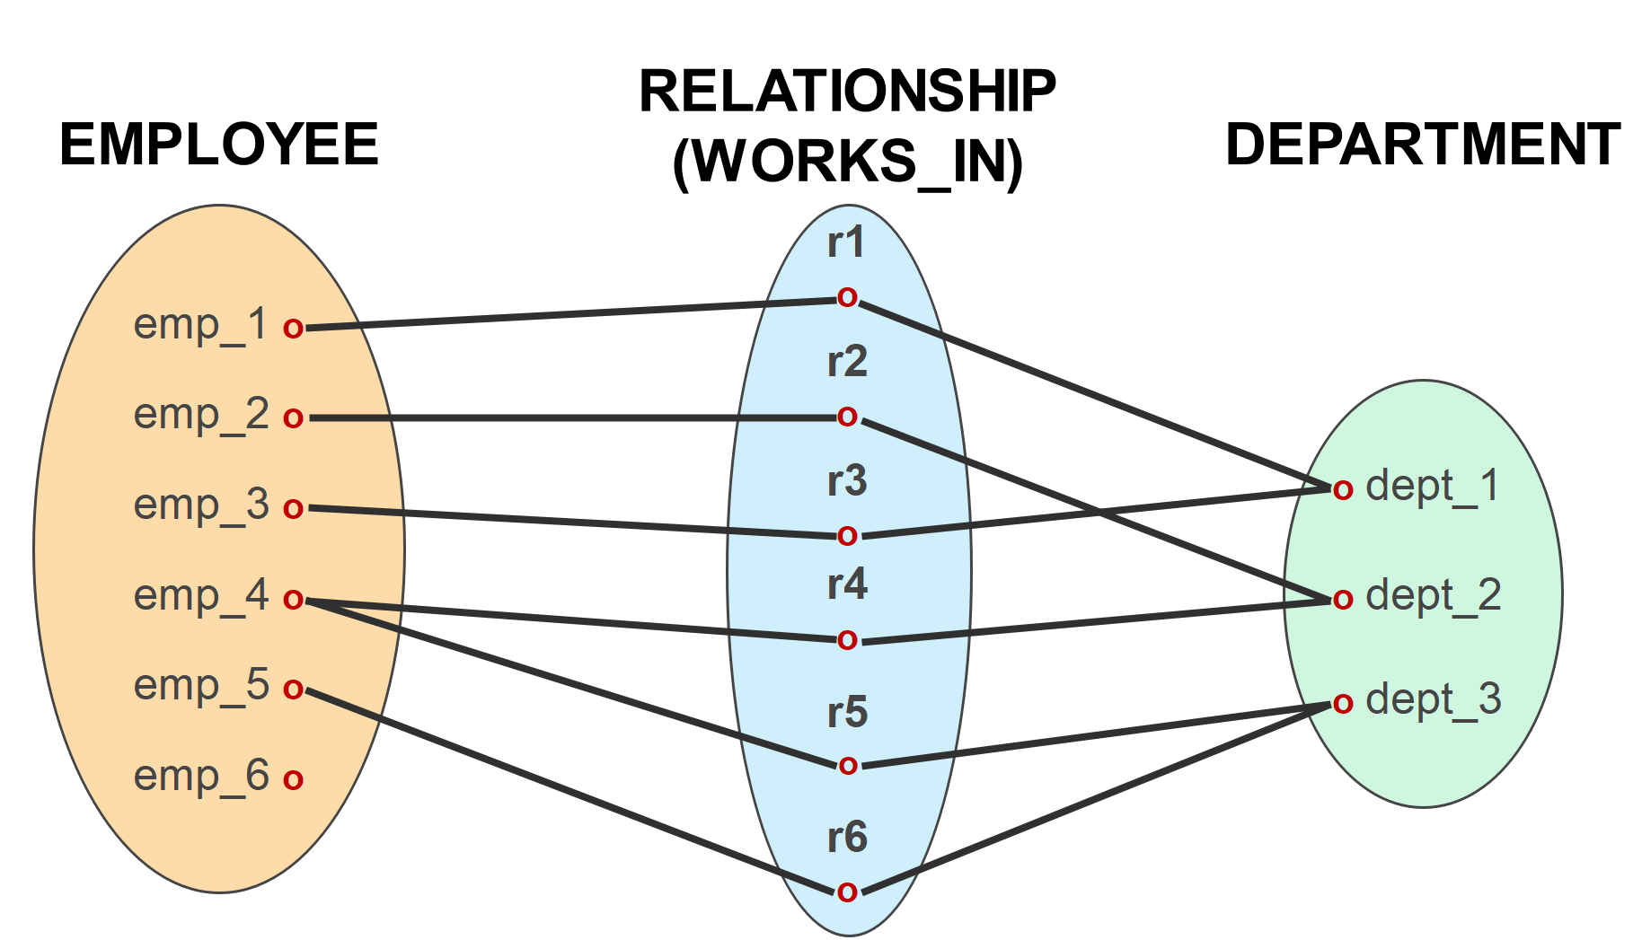

Figure.1

Which of the following relationships are solved and represented by the above figure?

* 1. **1:1** relationship between EMPLOYEE and DEPARTMENT and total participation from EMPLOYEE and total participation from DEPARTMENT
  2. **1:M** relationship between EMPLOYEE and DEPARTMENT and partial participation from EMPLOYEE and partial participation from DEPARTMENT
  3. **M:M** relationship between EMPLOYEE and DEPARTMENT and partial participation from EMPLOYEE and total participation from DEPARTMENT
  4. **M:1 relationship between EMPLOYEE and DEPARTMENT and total participation from EMPLOYEE and total participation from DEPARTMENT**

1. Suppose we map the following ERD (Figure 2) to the relations T1(A, B) and T2(B, C). The CREATE table statement for T2 is defined as the following:

CREATE TABLE T2(B SERIAL PRIMARY KEY, C INT).

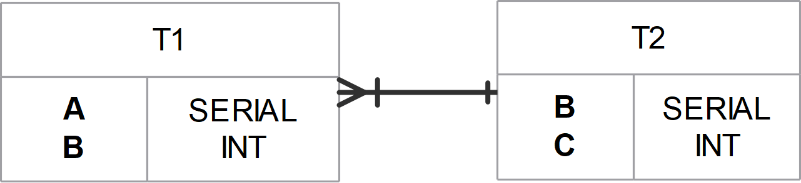

Figure. 2

Which one of the following create table statements would be correct for T1, enforcing the FK and relationship?

* 1. CREATE TABLE T1(A SERIAL PRIMARY KEY UNIQUE, B INT, FOREIGN KEY NOT NULL);
  2. CREATE TABLE T1(A SERIAL PRIMARY KEY, B INT NOT NULL REFERENCES T2(B));
  3. CREATE TABLE T1(A SERIAL UNIQUE, B REFERENCES T2(B));
  4. CREATE TABLE T1(A SERIAL, B INT);

**CREATE TABLE T1(A SERIAL PRIMARY KEY, B INT NOT NULL REFERENCES T2(B));**

1. In a manufacturing industry labourers are given different jobs on different days and each job has its own monthly basic and monthly special rates as wages to be paid to labourers. A worker is not given more than one type of job on a day. A database designer is given the job to design database for above situation and the designer designs a draft of one of the tables as:

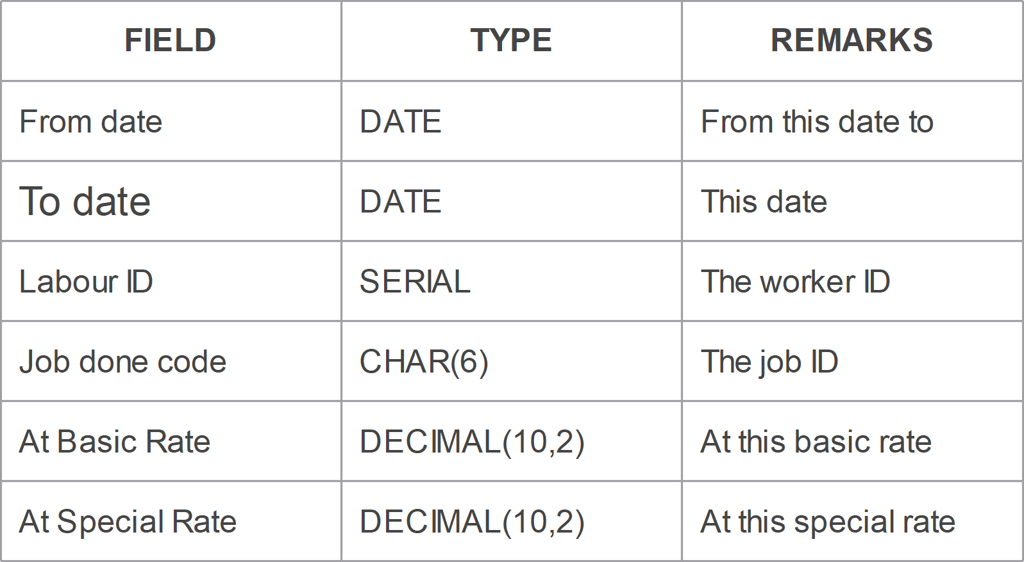

Fig. 3

Draw an ERD for the above situation that represents the relationship between **job** and **labour** (place each attribute to the correct table along with data type/size).

***Create a new database*** in your VM machine named **lab1** and paste the provided SQL code [[dbprin_lab1](https://portdotacdotuk-my.sharepoint.com/:u:/g/personal/val_adamescu_port_ac_uk/ERaxb665EYhJixxuKvnfX0QB3Oa2gAOmRCiSxi0FBJ4MfQ?e=N3bUTI)] into the database. Analysing the provided ERD (Figure 4) and the code, provide answers for the following questions.

***Note:*** *You should format ALL your queries for the optimal output using appropriate column names and CONCAT where available (e.g., instead of “cus_name” it should be “Customer Name”).*

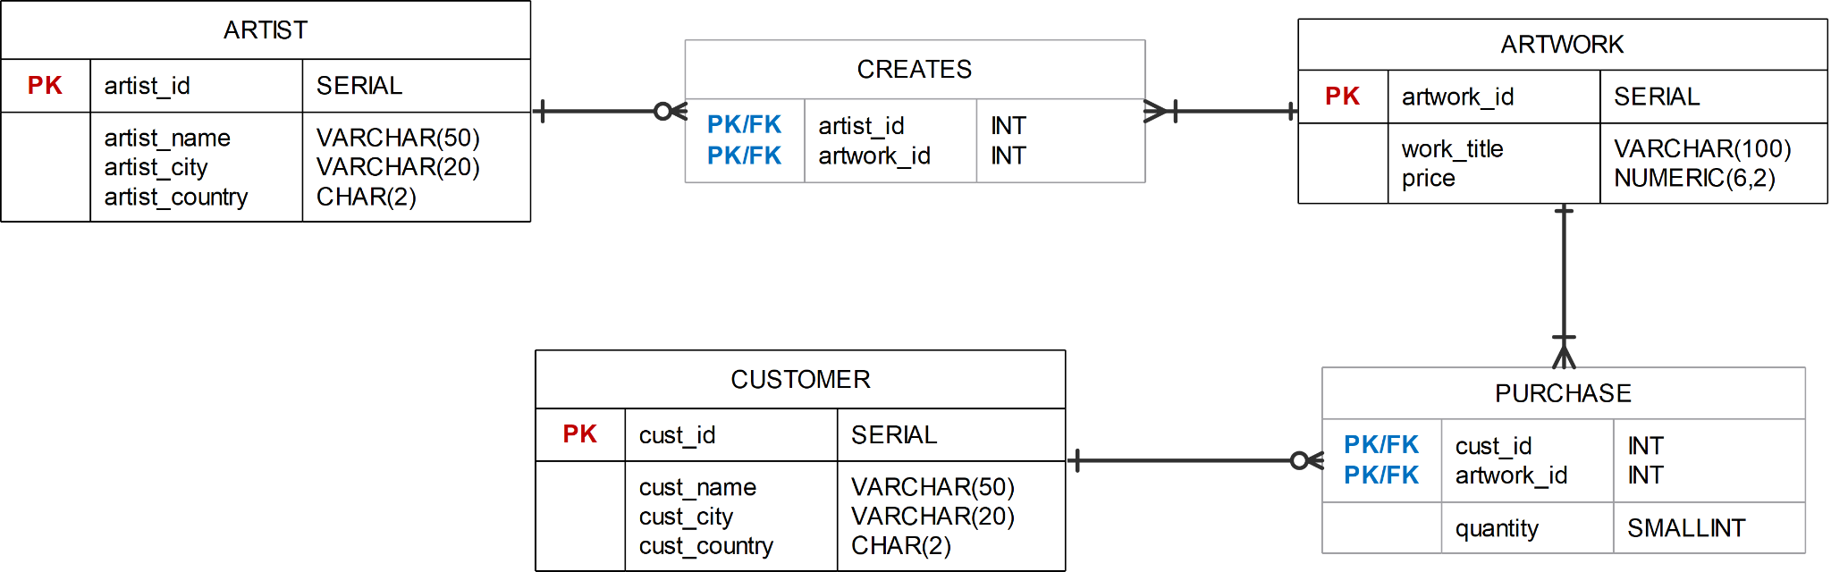

Fig. 4

1. Find the name of the artist who has created the Artwork titled ‘*Rainbow*’.

1. Find the titles of the Artworks created by ‘*Lolo*’.

1. Find the names of customers who have bought an artwork priced no more than £200. List the customer’s name, artwork title and the price. Add the £ sign to the output and order on price from lowest to highest.